**Air Travel – Going places from Negative Publicity to Factual Safety as a Society**

Travel safety is of utmost importance ever since the traveling has become integral part of the human society – be it for business, leisure, education, family events or enthusiastic exploration.

Amongst all the different modes of travel like ground, water, air – Air Travel is lauded as the fastest amongst all when it comes to time and comfort. “But what about safety?”, people might be puzzled. Especially after the recent media news and reports which have been flashing the reports about dangers involved siting the unfortunate events of recent times. Let’s find out.

* ***U.S. Air travel vs. Road travel fatalities:***

First, let’s look at the ***US fatalities statistics for the Air travel vs. Road travel during years 1994 – 2019***.

1. The total fatalities counts
2. The fatalities rate per 100M miles of travel

Total fatalities counts

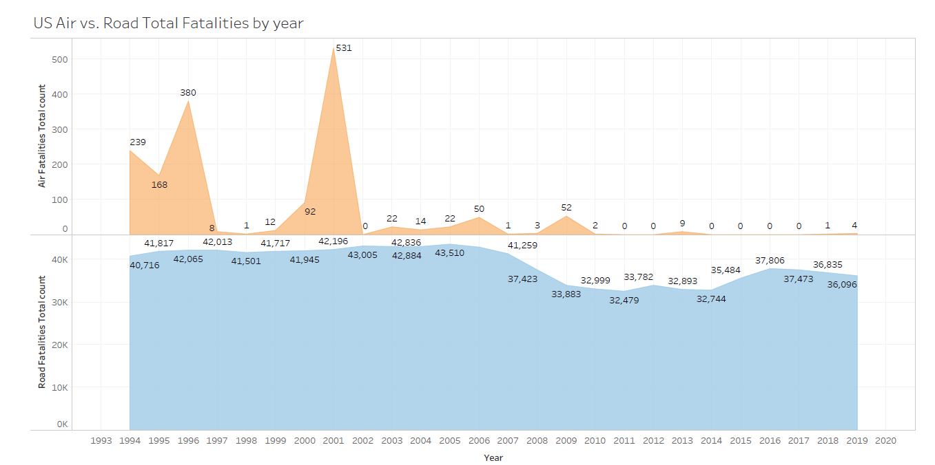

Fatalities rates per 100M miles of travel

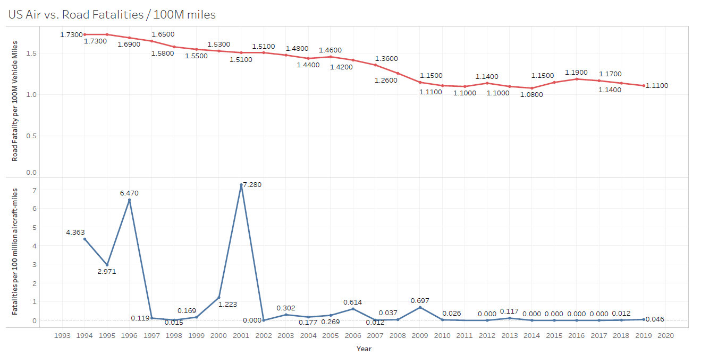

We can see while the Air travel domestically within US has gotten safer as we progress from 1994 – 2019 : Highest Air travel Fatalities encountered back in 2001 at 531, however it is down to near zero levels for the past ten years between 2010 to 2019. This is reflected on the fatalities rates for the Air travel as well with fatalities rates being down from 4.36 back in 1994 to rate of 0.04 in 2019. On the other hand, Road travel fatalities have only gone down from 40,000+ levels to around 36,000+ in the same 25 year timeframe. The fatalities rate as well is still lingering around 1.11 in 2019 per 100M miles of road travel.

* ***US State wise fatalities maps:***

To add another aspect to the above fatalities statistics for the Road Travel, we can also look at the ***US State wise fatalities maps*** which does underline that road travel fatalities are widely affecting across all of the US states in terms of number of fatalities on account of vehicle miles traveled, fatal incidents and fatality rates per 100M miles of vehicle travel. ***It is evident that higher the number of miles traveled, higher is the fatalities counts and rates, via road travel.***

**Fatalities and Vehicle Miles traveled for the U.S. States**

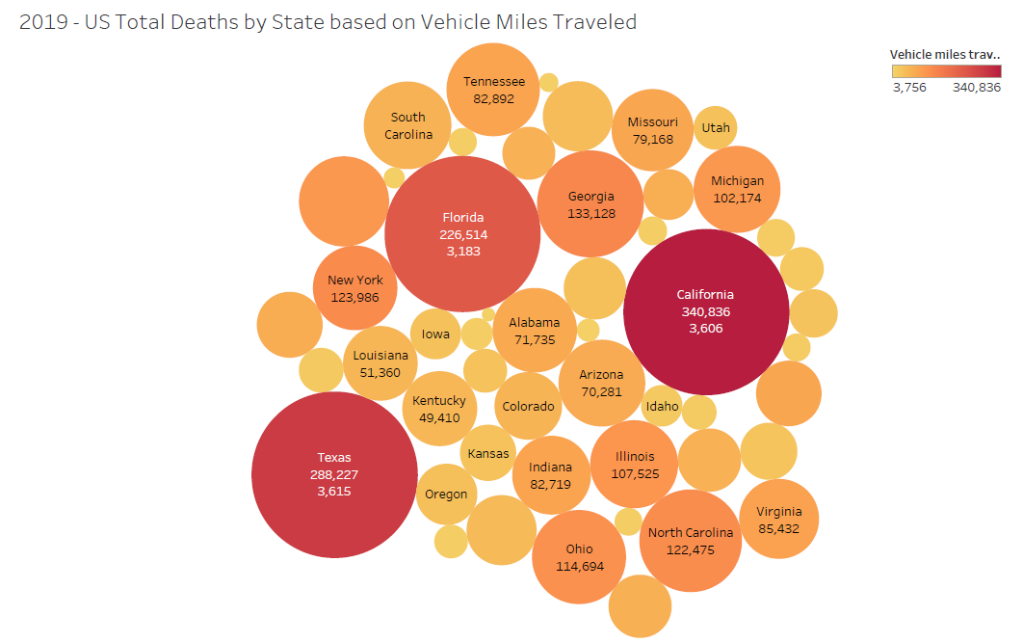

**Fatal Car Crashes by U.S. States**

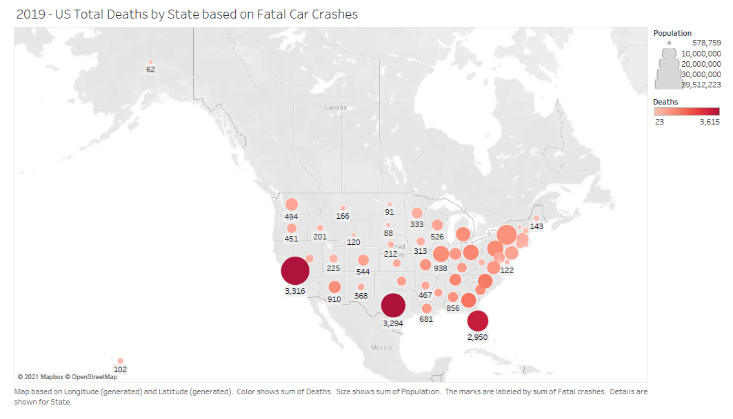

**Fatalities Rates for US states**

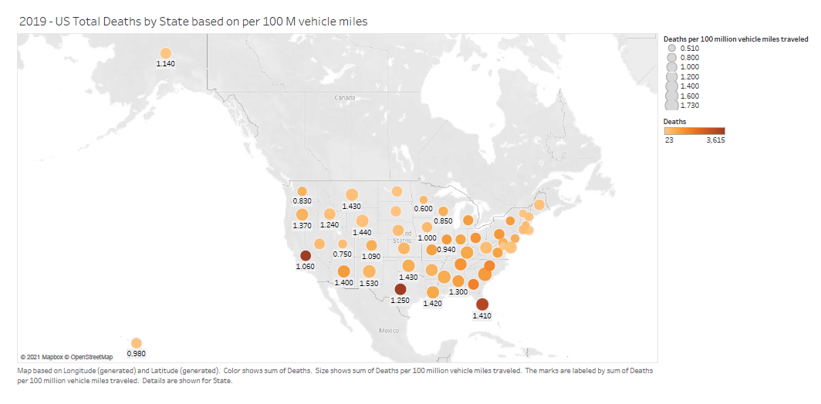

* ***Worldwide Airlines operations and safety***

Finally, we will review the ***Worldwide Airlines operations and safety data*** as another measure for the larger picture.

**Worldwide Airlines – Number of Flight Departures**

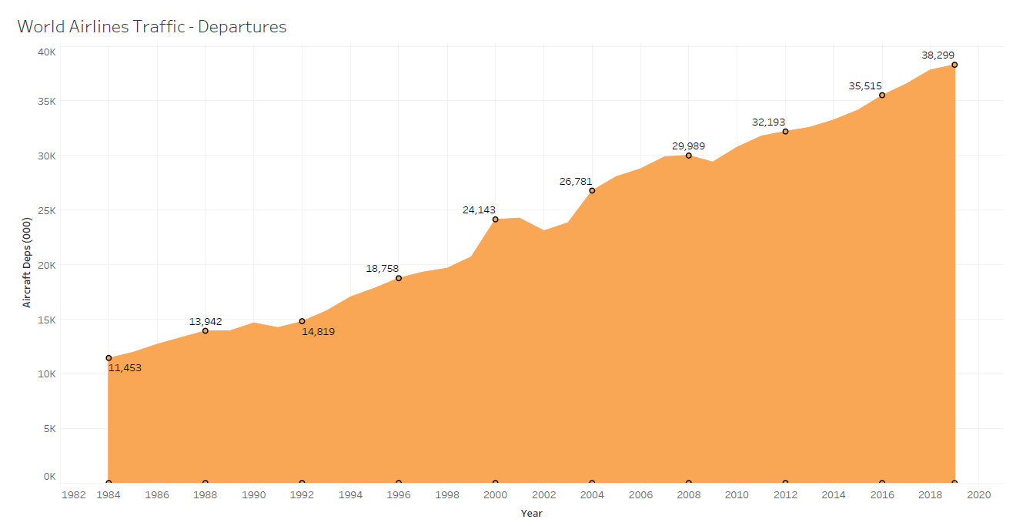

**Worldwide Airlines – Aircraft Travel Distances Kilometers (in millions)**

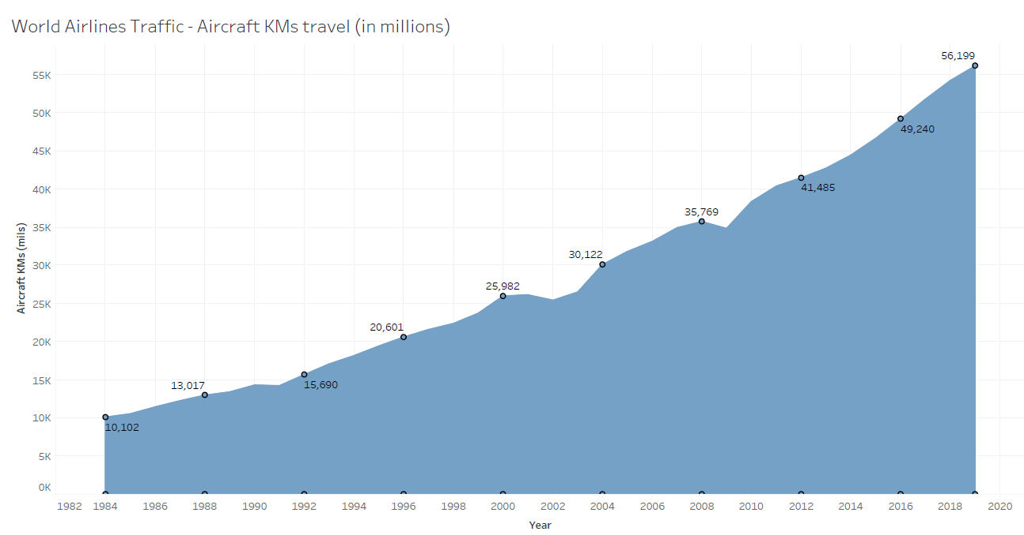

**World wide Air Travel Incidents and Fatalities statistics (1984 – 2014)**

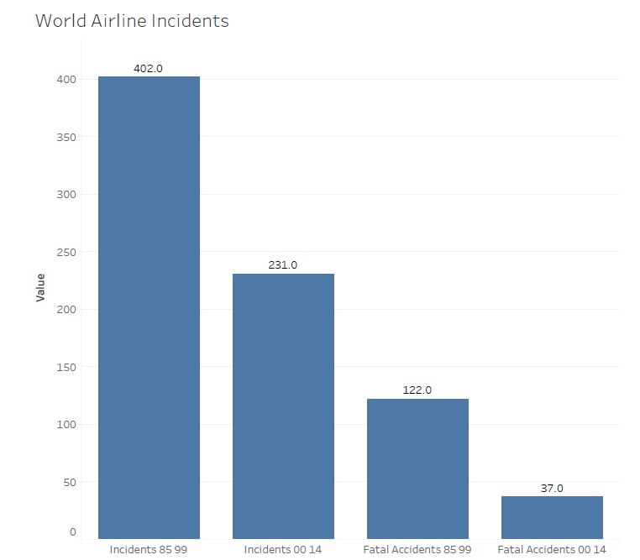 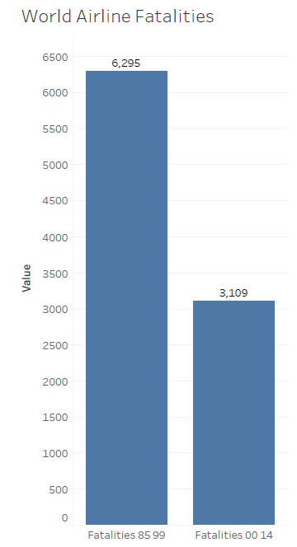

Above statistics clearly indicate – while the Worldwide Airlines Operations have been in Upward trajectory steadily considering factors like number of Flights Departures and the Aircraft Travel distance between 1984 to 2019, there is clear Significantly Downward trend in Worldwide Airlines adverse incidents and fatalities data on 3 aspects : Number of incidents, Number of Fatal accidents and Number of total fatalities between 1985 to 2014. This gives another ***booster to Air Travel that despite the increased operations and travel coverage, the adverse and fatal incidents have greatly decreased in the past 25 – 30 years***.

***Conclusion (Do I even need to state the obvious? 😉):***

Air Travel has become increasingly safer as compared to Road Travel on variety of parameters like total fatalities and incidents, fatality rates. The fact check has been performed not only for the air travel within U.S., but also for the ever so increasing worldwide air travel.

Hope you feel enlightened with the Safety aspects of Air Travel now. Do you already feel the newly grown wings of an Eagle on your sides? What are you waiting for then? FLY higher and conquer the limitless Skies! *Bon Voyage*.

**References:**

1. fivethirtyeight/data. (n.d.). GitHub. <https://github.com/fivethirtyeight/data/tree/master/airline-safety>
2. Fatality Analysis Reporting System (FARS), FHTSA. <https://www-fars.nhtsa.dot.gov/Trends/TrendsGeneral.aspx>
3. <https://www.bts.gov/content/us-air-carrier-safety-data> (scraped the necessary data)
4. <https://www.airlines.org/dataset/world-airlines-traffic-and-capacity-2/> (Scraped the required data for number of departures and miles traveled by World Airline)
5. <https://www.iihs.org/topics/fatality-statistics/detail/state-by-state> (formatted the data in useful excel file)